COURAGE My Children, COURAGE Pray No More Abortions
February 9, 2017
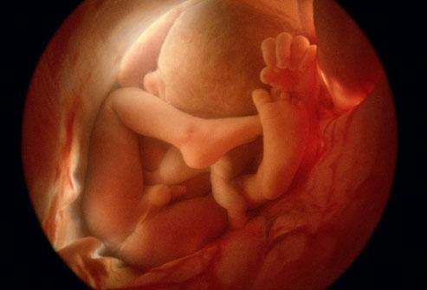
May the courage Jesus had on the way to Calvary strengthen all of us on this journey.

Well, my dear ones, you are making inroads with your prayers and offerings. And the Lord is encouraging you today. We still have a ways to go, so Courage and Endurance are what we are called to persevere in as we cleave to Jesus.

He began speaking, "Courage. Courage in suffering, My Children. We are not out of the woods yet with your President and much intercession is needed to move on the hearts of those who are resisting him and causing delays. They are making it very hard for him to initiate the changes that have to be made.

"But they will bend. I, Myself, will see to it and we will get past this point. But it is going to take much perseverance in prayers and offerings, especially for your Senate.

"My Christian people, choose wisely those who represent your region. There are traitors in the Senate who are bought out by the one world government and you put them in office. Now that their agendas have been exposed, I plead with you to make better decisions in the future. You do not want to live under the rule of corrupt men who are endorsed by Satan. But because the many in your nation have been moved by personality and appearance…

And I might add on my own - the media. The corrupt, paid-for media...

He continues, "But because the many in your nation have been moved by personality and appearance, they have been deceived into voting for the Destroyers. Yes, I give them this name, The Destroyers, because they work for The Destroyer.

"The choice has been given into your hand, because you are a democracy, but you must go deeper in your understanding of who is on the enemy’s side and who is on My side. Once you have determined that, it is your prerogative, your honor and your duty to pray and vote them into office and pray behind them as they move forward.

"We are going to win this but not without casualties and suffering and that is why I am asking you to receive your courage from Me. Those of you who are suffering, meditate upon the wounds in My hands and feet and side as well as the head wounds when I was crowned with scorn. This same scorn is alive and well in your government, your Senate and even in the House of Representatives. It calls for patient endurance. If you have prayed for your government, you can be sure that whatever sufferings you are now enduring, whether it be physical or at work and in the home, what you suffer is being taken as a sweet smelling sacrifice and being offered to the Father that His will be done in your nation.

"Nothing you are suffering in this hour is in vain or wasted.

"Do not grow weary in well-doing. Hold fast to My promises and know that the more you resemble Me, the more powerful your prayers are.

"The souls of innocent little children also carry much weight before the Father. They may not understand politics, but they understand killing babies in their mother’s wombs. And with this on their heart, they will pray as powerfully as anyone can pray. Ask them to pray that no more innocent babies will be killed in America, and even in the world, but especially here - the land of freedom and safety for all but the babies in their mother’s wombs.

"I am standing with you, America. I am fighting for you and the freedoms you were to represent. Although there was paganism in the founding of your country, I have inspired many of the principles that were written into your constitution with a mind to someday making you a model nation of morality to the world.

"The abortions MUST stop, because My Father’s wrath will not tolerate this heinous sin. Indeed, America has been the Great Harlot. Unless that changes, she will reap the justice she deserves.

“Indeed America has been the great harlot and unless that changes she will reap the justice she deserves. But because of the good that Americans have done in tending to the sick and third world nations - the poor of the world. Because of the efforts of many missionaries and your support of them, My Father’s hand has been stayed for yet another season in anticipation that things will change under this administration.

"Pray very hard for President Trump, that he will feel My conviction over the sins of this nation, especially abortion. Pray that the conviction goes very, very deep and that he stands against all pressure and opposition that will be leveled against him as this agenda moves forward.

"I, in turn, will protect him.

"Your dedication to prayer has made all the difference - that at the present time you are not running from the North Koreans and Chinese and Russians, but you are living in unwalled cities, reaping fruit from your own fruit trees and bringing in the harvest and eating well. Had things not changed during this election, you would be looking at devastation and starvation right now.

"Take My words with great seriousness. Stand in Courage, My Courage. Meditate often on My Passion, even the remembrance of My steps to Calvary. You will gain the strength to persevere. I am with you and working on your behalf that My Will be done, My Kingdom come, on Earth as it is in Heaven."

